**[Project]**

**DETAIL DESIGN DOCUMENT**

**Data design**

**Project Code:**

**Document Code: <Project code>-DD – v<Version>**

1. **Lê Trọng Phú**
2. **Lê Tất Hùng**
3. **Hoàng Huy**
4. **Nguyễn Hữu Tài**

### <Location, issued date of the Document>

**RECORD OF CHANGE**

#### *A - Added M - Modified D – Deleted

|  |  |  |  |  |
| --- | --- | --- | --- | --- |
| Effective Date | Changed Items | A* M, D | Change Description | New Version |
|  |  |  |  |  |
|  |  |  |  |  |
|  |  |  |  |  |
|  |  |  |  |  |
|  |  |  |  |  |
|  |  |  |  |  |
|  |  |  |  |  |
|  |  |  |  |  |
|  |  |  |  |  |
|  |  |  |  |  |

**SIGNATURE PAGE**

**ORIGINATOR:**<Name> <Date>

#### <Position>

**REVIEWERS:** <Name> <Date>

#### <Position>

<Name, if it’s needed> <Date>

<Position>

**APPROVAL:** <Name> <Date>

#### <Position>

MỤC LỤC

# MÔ HÌNH DỮ LIỆU QUAN HỆ

Đưa mô hình dữ liệu quan hệ vào mục này.

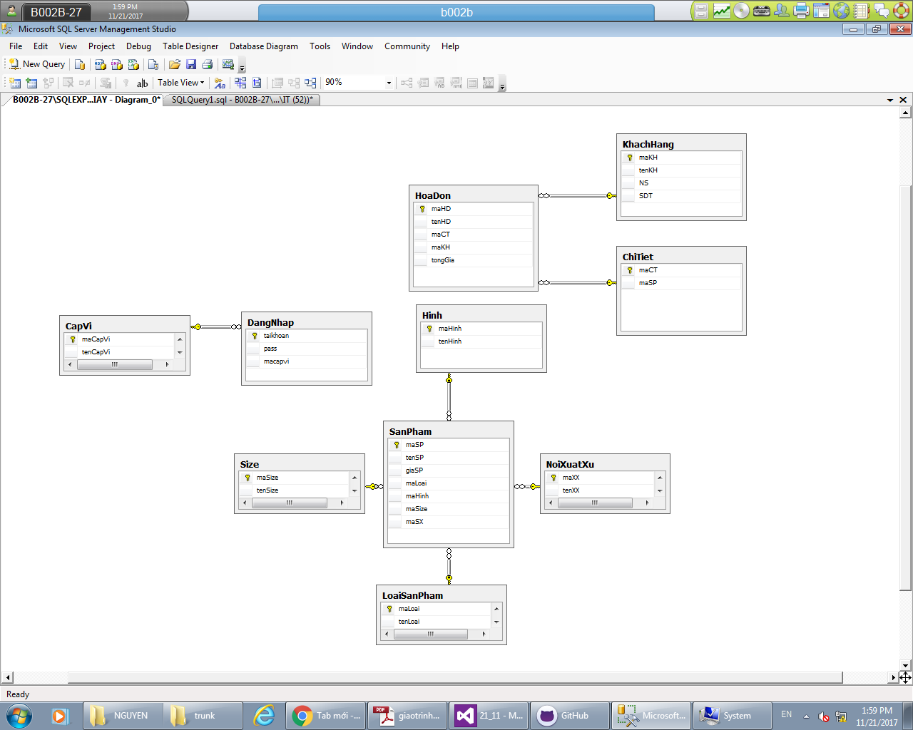

1. **DATABASE**

<List of tables and brief description>

|  |  |  |
| --- | --- | --- |
| **No** | **Table Name** | **Description** |
| 1 | DangNhap | DangNhap(TaiKhoan,pass,maCapVi) |
| 2 | CapVi | CapVi(maCapVi,tenCapVi) |
| 3 | HoaDon | HoaDon(maHD,tenHD,maCT,tongGia) |
| 4 | KhachHang | KhachHang(maKH,tenKH,NS,SDT) |
| 5 | ChiTiet | ChiTiet(maCT,maSP) |
| 6 | SanPham | SanPham(maSP,tenSP,giaSP,maHinh,maSize,maXS) |
| 7 | Hinh | Hinh(maHinh,tenHinh) |
| 8 | NoiXuatSu | NoiXuatSu(maXS,tenXS) |
| 9 | Size | Size(maSize,tenSize) |
| 10 | LoaiSanPham | LoaiSanPham(maLoai,tenLoai) |

## Table DangNhap

|  |  |  |  |  |  |  |  |  |  |  |
| --- | --- | --- | --- | --- | --- | --- | --- | --- | --- | --- |
| **No** | **Field Name** | **Type** | **Length** | **Size** | **Null** | **Unique** | **P/F Key** | **Default** | **Check** | **Description** |
| 01 | taikhoan | nvarchar | 50 |  | x |  | P |  |  |  |
| 02 | pass | navrchar | 50 |  |  |  |  |  |  |  |
| 03 | macapvi | nvarchar | 50 |  |  |  |  |  |  |  |
|  |  |  |  |  |  |  |  |  |  |  |

**2.2 table CapVi**

|  |  |  |  |  |  |  |  |  |  |  |
| --- | --- | --- | --- | --- | --- | --- | --- | --- | --- | --- |
| **No** | **Field Name** | **Type** | **Length** | **Size** | **Null** | **Unique** | **P/F Key** | **Default** | **Check** | **Description** |
| 01 | maCapVi | nvarchar | 50 |  | x |  | P |  |  |  |
| 02 | tenCapvi | navrchar | 50 |  |  |  |  |  |  |  |

**2.3 SanPham**

|  |  |  |  |  |  |  |  |  |  |  |
| --- | --- | --- | --- | --- | --- | --- | --- | --- | --- | --- |
| **No** | **Field Name** | **Type** | **Length** | **Size** | **Null** | **Unique** | **P/F Key** | **Default** | **Check** | **Description** |
| 01 | maSp | nvarchar | 50 |  | x |  | P |  |  |  |
| 02 | tenSp | navrchar | 50 |  |  |  |  |  |  |  |
| 03 | giaSP | nvarchar | 50 |  |  |  |  |  |  |  |
|  | maLoai | nvarchar |  |  |  |  |  |  |  |  |
|  | maHinh | nvarchar |  |  |  |  |  |  |  |  |
|  | maSize | nvarchar |  |  |  |  |  |  |  |  |
|  | maXS | nvarchar |  |  |  |  |  |  |  |  |

**2.4 hinh**

|  |  |  |  |  |  |  |  |  |  |  |
| --- | --- | --- | --- | --- | --- | --- | --- | --- | --- | --- |
| **No** | **Field Name** | **Type** | **Length** | **Size** | **Null** | **Unique** | **P/F Key** | **Default** | **Check** | **Description** |
| 01 | Mahinh | nvarchar | 50 |  | x |  | P |  |  |  |
| 02 | tenhinh | navrchar | 50 |  |  |  |  |  |  |  |

**2.5 noi xuat xu**

|  |  |  |  |  |  |  |  |  |  |  |
| --- | --- | --- | --- | --- | --- | --- | --- | --- | --- | --- |
| **No** | **Field Name** | **Type** | **Length** | **Size** | **Null** | **Unique** | **P/F Key** | **Default** | **Check** | **Description** |
| 01 | maXX | nvarchar | 50 |  | x |  | P |  |  |  |
| 02 | tenXX | navrchar | 50 |  |  |  |  |  |  |  |

**2.6 loai san pham**

|  |  |  |  |  |  |  |  |  |  |  |
| --- | --- | --- | --- | --- | --- | --- | --- | --- | --- | --- |
| **No** | **Field Name** | **Type** | **Length** | **Size** | **Null** | **Unique** | **P/F Key** | **Default** | **Check** | **Description** |
| 01 | maLoai | nvarchar | 50 |  | x |  | P |  |  |  |
| 02 | tenLoai | navrchar | 50 |  |  |  |  |  |  |  |

**2.7 size**

|  |  |  |  |  |  |  |  |  |  |  |
| --- | --- | --- | --- | --- | --- | --- | --- | --- | --- | --- |
| **No** | **Field Name** | **Type** | **Length** | **Size** | **Null** | **Unique** | **P/F Key** | **Default** | **Check** | **Description** |
| **01** | **maSize** | **nvarchar** | **50** |  | **x** |  | **P** |  |  |  |
| 02 | tenSize | navrchar | 50 |  |  |  |  |  |  |  |

**2.8 hoa don**

|  |  |  |  |  |  |  |  |  |  |  |
| --- | --- | --- | --- | --- | --- | --- | --- | --- | --- | --- |
| **No** | **Field Name** | **Type** | **Length** | **Size** | **Null** | **Unique** | **P/F Key** | **Default** | **Check** | **Description** |
| 01 | maHoaDon | nvarchar | 50 |  | x |  | P |  |  |  |
| 02 | tenHoaDon | navrchar | 50 |  |  |  |  |  |  |  |
| 03 | maCT |  |  |  |  |  | F |  |  |  |
| 04 | maKhachHang |  |  |  |  |  | F |  |  |  |
| 05 | tongGia |  |  |  |  |  |  |  |  |  |

**2.9 Khach hang**

|  |  |  |  |  |  |  |  |  |  |  |
| --- | --- | --- | --- | --- | --- | --- | --- | --- | --- | --- |
| **No** | **Field Name** | **Type** | **Length** | **Size** | **Null** | **Unique** | **P/F Key** | **Default** | **Check** | **Description** |
| 01 | maKhachHang | nvarchar | 50 |  | x |  | P |  |  |  |
| 02 | tenKhachHang | navrchar | 50 |  |  |  |  |  |  |  |
| 03 | namSinh |  |  |  |  |  |  |  |  |  |
| 04 | SDT |  |  |  |  |  |  |  |  |  |

**2.10 chi tiet**

|  |  |  |  |  |  |  |  |  |  |  |
| --- | --- | --- | --- | --- | --- | --- | --- | --- | --- | --- |
| **No** | **Field Name** | **Type** | **Length** | **Size** | **Null** | **Unique** | **P/F Key** | **Default** | **Check** | **Description** |
| 01 | maChiTiet | nvarchar | 50 |  | x |  | P |  |  |  |
| 02 | tenSanPham | navrchar | 50 |  |  |  |  |  |  |  |
|  |  |  |  |  |  |  |  |  |  |  |
|  |  |  |  |  |  |  |  |  |  |  |